# EXPRESS EDUCATION SERVICES LIMITED – 2024

# PRIMARY LEAVING SPECIAL MOCK

**MATHEMATICS**

## Time allowed: 2hours 30 minutes

**Index No.**

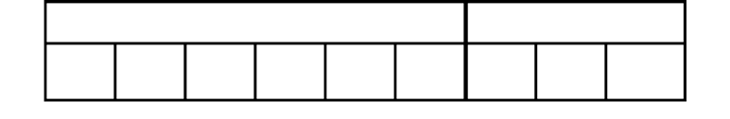

**Random No.**

**Personal No.**

**Candidate’s Name:**

**Candidate’s Signature:**

**DISTRICT ID NO.**

|  |  |  |  |
| --- | --- | --- | --- |
|  |  |  |  |

2024 SPECIAL MOCK

|  |  |  |
| --- | --- | --- |
| **FOR EXAMINERS ONLY** | | |
| **Qn. No.** | **MARKS** | **EXR’S NO** |
| 1 - 5 |  |  |
| 6 - 10 |  |  |
| 11 - 15 |  |  |
| 16 - 20 |  |  |
| 21 - 22 |  |  |
| 23 - 24 |  |  |
| 25 - 26 |  |  |
| 27 - 28 |  |  |
| 29 - 30 |  |  |
| 31 - 32 |  |  |
| TOTAL |  |  |

Read the following instructions carefully

**Do not write your school or District name anywhere on this paper.**

1. This paper has two sections **A** and **B.**

Section A has 20 questions and Section B has 12 questions. This paper has **16** printed pages.

1. Answer **all** questions. **All** the working for both sections .A and B must be shown in the spaces provided.
2. **All** working must be done using a **blue** or **black**

ball-point pen or fountain pen. Any work done in pencil other than diagrams will not be marked.

1. No calculators are allowed in the examination room.
2. Unnecessary changes in your work may lead to loss of marks.
3. Any handwriting that cannot easily be read may

lead to loss of marks.

1. Do not fill anything in the table indicated:

**“For Examiners’ Use Only”** and boxes inside the question paper.



Turn Over

# SECTION A: 40 MARKS

Answer all questions in this section Questions **1** to **20** carry two marks each

* 1. Work out: 18  2
  2. Express “Four hundred forty thousand four” in numerals.
  3. Describe the shaded region.



**H G**

* 1. Simplify: 5q – 3q + q
  2. 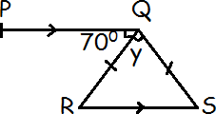In the diagram below, line **PQ** is parallel to the RS and **QRS** is an Isosceles triangle. Study it carefully and use it to answer the question that follows.

a

Find the value of y.

* 1. Round off **64.98** to the nearest tenths.
  2. Work out the number which has been prime factorized to give { 21, 22, 23, 31}
  3. Simplify: -5 - -7
  4. Write the integers represented by the arrows x and z on the number line below.

*x*

*z*

-5 -4 -3 -2 -1 0 1 2 3 4

* + 1. *x* ………………………..
    2. *z* ………………………..
  1. Express 0.3636*…...* as a common fraction in its simplest form.
  2. The faces of a cube are numbered from 1 to 6. The cube is rolled once. What is the probability that a square number will show on the top face?
  3. Find the Range of the next two numbers in the sequence. 1, 3, 6, 10, 15, ,
  4. During a debate, each side gave 20 views. If the secretary was awarding 3 points for every defended view and deducting a point for every opposed view. How many views did the proposers defend if their final score was 72 points?
  5. Express 2,407 in scientific form.
  6. In a tin, the ratio of blue pens to red pens is **3:2**. If there are **6** more blue pens than red pens, how many pens are in the tin altogether?

16. Water in a 20 litre jerycan leaks at a rate of half a litre every 40 minutes.

How much water will be left in the jerycan after 4 hours?

1. Amos deposited 120,000shs in a bank which offers 2% for a period of 6 months. How much money will he get back?

1. Workout (3. 3 x 125) – (3.3 x 25) using distributive method.

1. Solve the inequality: 3 ≥ 7 – 2h
2. Expand the number shown on the abacus below using powers of ten.

H T O

# SECTION B: 60 MARKS

Answer **all** questions in this section

Marks for each question are indicated in brackets

1. In a class, 30 pupils like science (S), 10 pupils like both science and mathematics (M), d like only one subject while 6 pupils like neither of the two subjects.
   1. Use the given information to complete the Venn diagram below (02 marks)

*ε*

S

M

………

10

………

6

* 1. Given that 20 pupils do not like science, find the number of pupils who like only one subject. (02 marks)

1. (a) On the clock face below, show nineteen minutes to

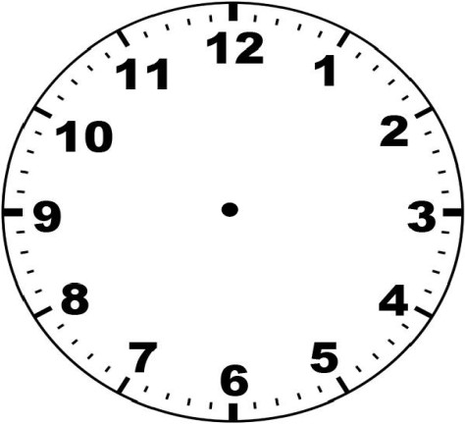nine o’clock.

(02 Marks)

(b) Primary Seven pupils went to bed at a quarter past 9

o’clock in the evening and woke up at a quarter to 5 o’clock in the morning. For how long were they in bed? (02 Marks)

1. Adongo had sh 60, 000 and bought the following items in the table below.

|  |  |  |  |
| --- | --- | --- | --- |
| **Item** | **Quantity** | **Unit cost** | **Total cost** |
| Cooking oil | litres | Sh | Sh .17,500 |
| Rice | 2kg | Sh .4500 | Sh |
| Sugar | kg | Sh .3500 | Sh.1,750 |
| Meat | 2kg | Sh | Sh |
|  | **Total expenditure** | | **Sh.56,250** |

* 1. Complete the table above correctly. (Show the working)

(5marks)

* 1. If she was given a discount of 10%, how much money did she pay for the items? (1mark)

1. A Primary Seven boy rolled a bicycle wheel of radius 28cm along a path as shown below.

28cm

528metres

* 1. Taking P. as 22 , how many centimeters did the wheel

7

move in one rotation? (2marks)

b) Find the maximum number of revolutions made by the wheel through the entire path. (3marks)

1. Tap A fills a tank in 3 minutes and Tap B fills the same tank in t minutes.

If the two taps fill 7 of the tank in one minute. Find the

value of t.

12

(3marks)

(b) If 280 litres of water is filled by the two taps in one minute. Find the capacity of the tank. (3marks)

1. The area of the two equal circles is 308cm2 .Study it carefully and calculate the area of the unshaded part.

(Take 𝜋 = 22) (5 marks)

7

## Use the co- ordinate graph below to complete the table below. (5 marks)

|  |  |  |  |  |  |
| --- | --- | --- | --- | --- | --- |
| **points** | **A** | **B** | **C** | **D** | **E** |
| **X** | **……..** | **…..…** | **…….…** | **………** | **………...** |
| **Y** | **……** | **…..…** | **………** | **………** | **……...** |

1. Robert was sent to the food store on Monday 27th of May to count the number of pumpkins to be prepared daily for breakfast. He counted using only the fingers of one hand starting with one.

If there was 96 pumpkins, on which finger did he stop?

(2marks)

b) The last breakfast meal of pumpkins was served 14th July, How many pumpkins were eaten each day?

(3marks)

1. Kasirye bought 15 glasses for sh 800 each. As he was transporting them, some glasses got broken and sold the rest at sh 1,200 getting a profit of 10%.

Find how many glasses got broken. (5 marks)

30(a) Nakityo distributed her wealth of sh.5,400,000 to her three daughters. Stella got a quarter of what Jane got and Sarah got half of what Stella and Jane got. How much wealth did each daughter get? (3 marks)

(b) Kafeero bought a T.V set and sold it to Dan for sh.345,000 making a profit of 15%. Dan then sold it to Kyampaire at a loss of 5%.

How much did Kyampaire pay for the T.V set? (2marks)

1. Town M is 240 kilometres away from town N. A bus and a taxi left town M for town N at 3:45p.m.

The bus was moving at an average speed of 72 kilometres per hour. At 4:30p.m, the bus was 18 kilometres ahead of the taxi.

At what time did the taxi reach town N travelling at the same speed? (5 marks)

1. Town **A** is **60km** west of town **B** and town **C** is **80km** away from town **B** on bearing of **1200**.

Turn Over

* 1. Draw a sketch to show the three towns. (1mark)
  2. Using **1 km** to represent **10 km**, draw an accurate diagrams showing the three towns. (3marks)
  3. Find the shortest distance from town **A** to Town **C** in kilometres (1mark)

2024 SPECIAL MOCK

**END**